We are 7 miles south of Cannon Beach and 7 miles north of Manzanita.
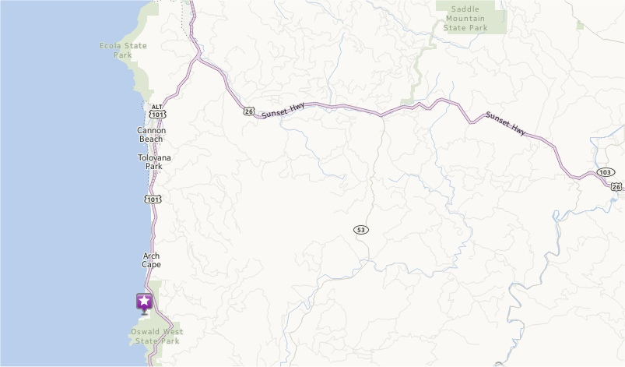
Turn west on Falcon Cove Road from Hwy 101 and go ¼ mile to Elk Flat Road.
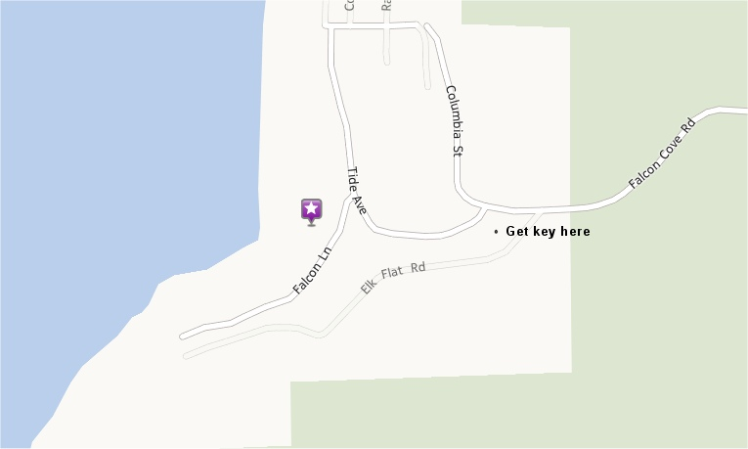
Turn left on Elk Flat Road and you’ll see our driveway on the right. Drive up the driveway to our house.

